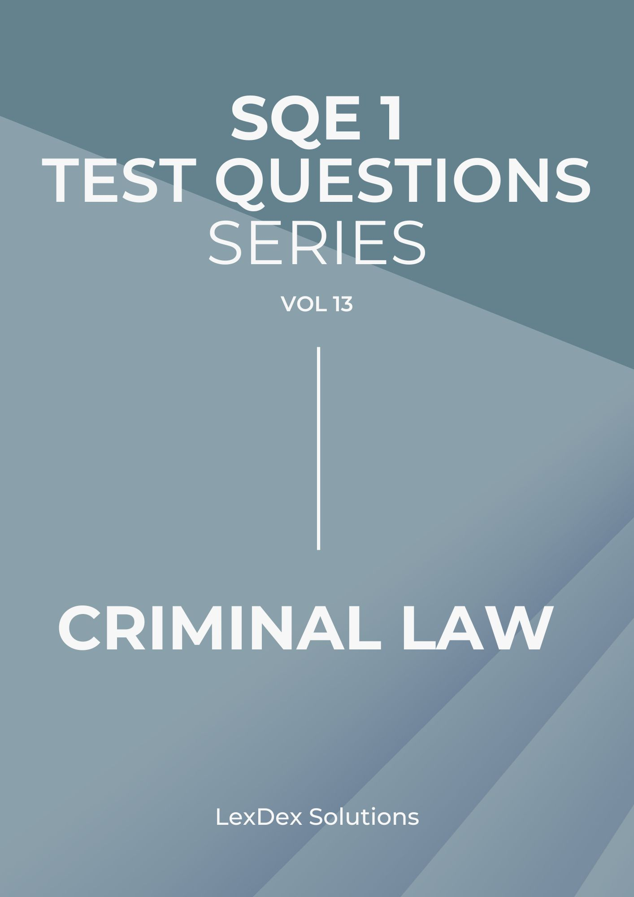

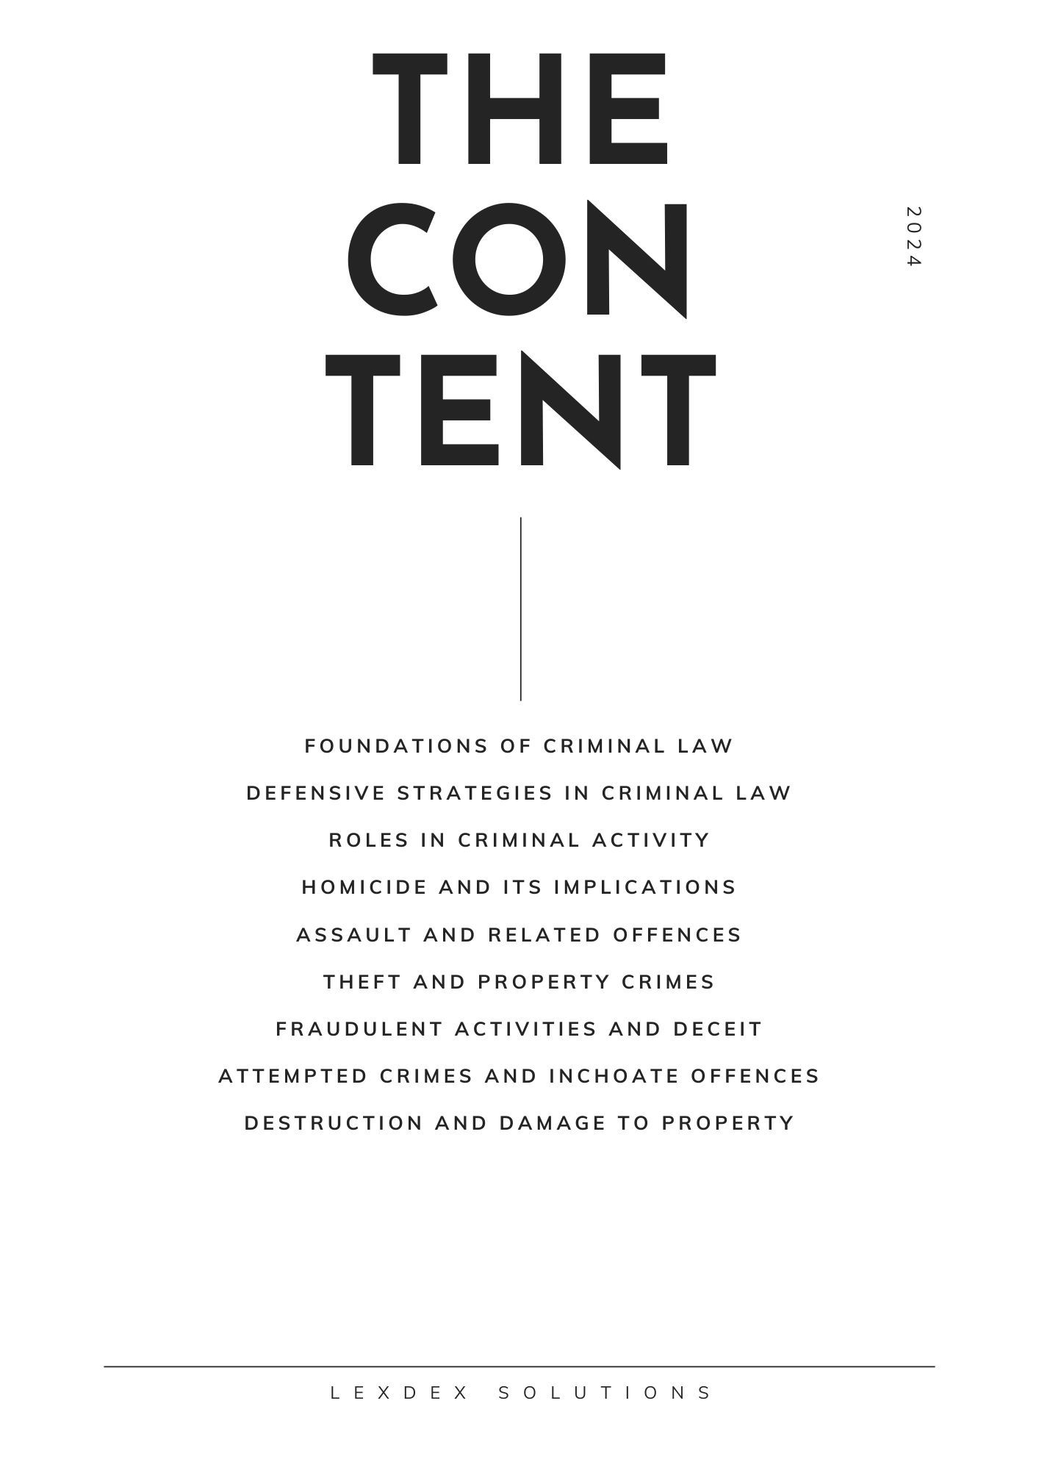

This document is a pre-view and contains only part of the questions.

Full version available:

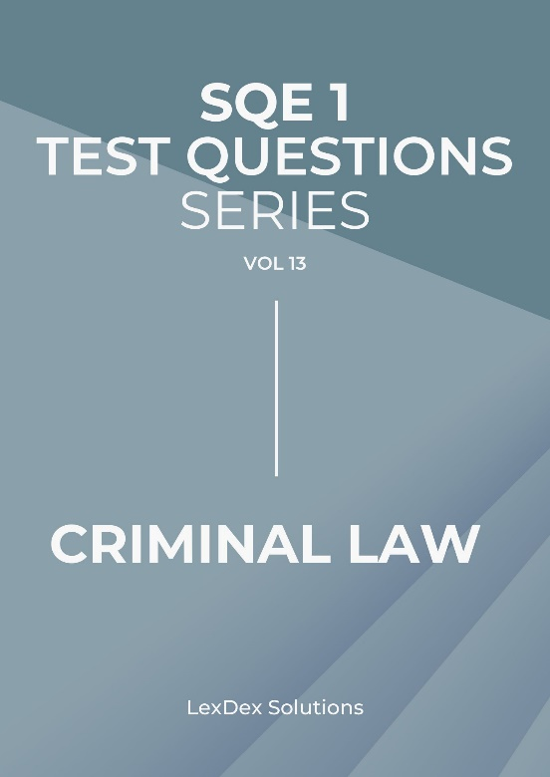

You can also get a complete set of 14 eBooks covering FLK1 and FLK2:
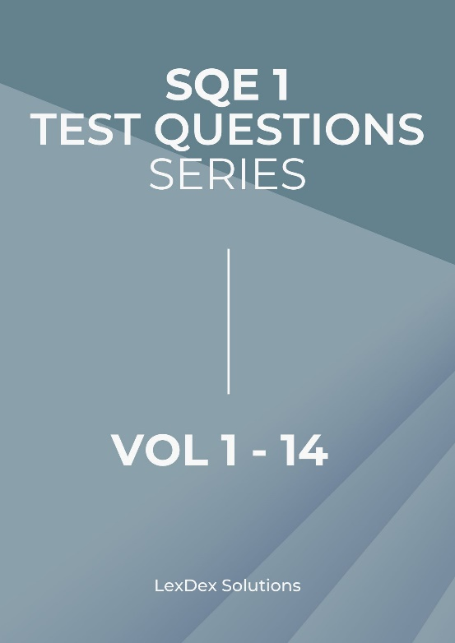

Or choose only those you need:

https://lexdex-solutions.uk/sqe-1-test-questions/

Also



Welcome to "90 SQE1 Test Questions – Criminal Law," your essential resource for preparing
for the Solicitors Qualifying Examination (SQE1).
This e-book is carefully crafted to provide you with a focused training experience,
specifically addressing the critical principles and frameworks of criminal law vital for
aspiring solicitors.
Within this e-book, you will discover a great range of test questions designed to mirror the
SQE1 exam format, allowing you to practice in a realistic and challenging environment.
Each question has been developed to reflect the most current legal standards and principles as
of September 2024, ensuring that you are studying with the most relevant and updated
information.
The questions encompass a wide variety of topics within criminal law, aligned with the SQE1
syllabus.
This diversity enables you to assess your understanding and application of key legal concepts,
bolstering both your knowledge and confidence as you prepare for the examination.
Our goal is to aid you not only in recalling information but also in grasping the underlying
principles and their implications in real-world scenarios. To enhance your learning
experience, each question is paired with explanations that illustrate the reasoning behind the
correct answers.
These insights will deepen your understanding of complex legal issues and support you in
making your way through the challenging environment of legal practice.
As you engage with this e-book, we encourage you to integrate it into your study routine
actively.
Whether you are reviewing specific legal principles or assessing your overall preparedness
for the SQE1, this resource is designed to be an invaluable partner in your journey.
Thank you for choosing "90 SQE1 Test Questions – Criminal Law" as part of your study
materials.
We wish you the best of luck as you take on this significant step in your legal career.

1. Foundations of Criminal Law
Question 1:
During a community festival, a street performer named Jake dazzles the audience with his
juggling act, which includes flaming torches. As he throws the torches into the air, one
accidentally slips from his grasp and strikes a spectator, resulting in a burn injury. The
spectator, furious and in pain, insists on taking legal action against Jake for the injury
sustained. Jake defends himself by stating that he has performed this act countless times
without incident and that he was careful throughout his performance. He argues that the
injury was purely accidental and that the spectator should have been more vigilant while
watching. The injured spectator, however, believes that Jake’s act was inherently dangerous
and that he should have been more responsible. In court, Jake must contend with the
argument of negligence raised by the prosecution, who claims that he did not take reasonable
precautions. The case raises questions about the standards of care expected in public
performances and whether Jake's actions meet those standards.
A. Jake's extensive experience as a performer should exempt him from liability for injuries.

B. The inherent risks associated with public performances mean that performers are not liable
for accidents, as the audience assumes some risk by attending.

C. Jake can be held liable for negligence if it is determined that he failed to act reasonably to
ensure audience safety during his act, regardless of his experience.

D. The spectator's inattentiveness mitigates Jake's responsibility for the injury, as he should
not be held accountable for someone else's lack of caution.

E. The festival organizers are solely responsible for any injuries that occur during
performances, as they have the duty to ensure safety.

Correct Answer: C. Jake can be held liable for negligence if it is determined that he failed to
act reasonably to ensure audience safety during his act, regardless of his experience.

Explanation: In this case, the court will examine whether Jake took reasonable precautions
during his performance to prevent injury to the audience. Negligence is established by
assessing whether a performer acted as a reasonable person would under similar
circumstances, particularly in the presence of potential dangers like fire. Jake's experience
does not automatically absolve him of responsibility if it is found that he acted recklessly or
without due caution. The prosecution's argument focuses on the standard of care expected
from performers, and if Jake did not meet that standard, he could be held liable. While
audience members do assume some risks, that does not negate a performer’s responsibility to
act safely. The other responses incorrectly suggest that experience or audience behaviour
completely negate liability, which is not how negligence law operates.

Question 2:

Question 3:

Question 4:

Question 5:

Question 6:

Question 7:

Question 8:

Question 9:

Question 10:

2. Defensive Strategies in Criminal Law
Question 1:

Question 2:
Maria is walking home late at night when she notices a man following her. Feeling
threatened, she pulls out her phone and calls a friend, speaking loudly to make it clear she is
not alone. The man continues to follow her, and Maria, growing more anxious, picks up a
large stick lying on the ground. When the man gets closer, she turns around and swings the
stick at him, shouting for him to back off. The man, caught off-guard, stumbles and falls,
hitting his head on the pavement. He later presses charges against Maria, alleging that she
attacked him without provocation. Maria insists that she believed she was about to be
assaulted and acted to defend herself. This case raises issues of pre-emptive self-defence and
the reasonable use of force in response to perceived threats.

A. Maria’s actions will likely be deemed excessive, as the man had not made any verbal or
physical threats towards her.

B. The fact that Maria used a weapon will automatically disqualify her from claiming self-
defence.

C. Maria could argue that her actions were justified as a pre-emptive strike, given the
circumstances and her fear of imminent harm.

D. The man's claim will likely prevail because he was not injured as a result of direct contact
with Maria’s actions.

E. The court will dismiss the case if it determines that Maria's use of the stick was a
proportionate response to the perceived threat.

Correct Answer: C. Maria could argue that her actions were justified as a pre-emptive strike,
given the circumstances and her fear of imminent harm.

Explanation: In criminal law, self-defence can sometimes extend to pre-emptive actions
taken to prevent an imminent attack. Maria's fear and perception of being followed late at
night could be considered reasonable grounds for believing she was in immediate danger. The
use of a weapon does not automatically disqualify a self-defence claim; rather, the focus is on
whether the response was proportionate to the threat. Option A assumes that a verbal or
physical threat is necessary to establish self-defence, but in cases of pre-emptive self-defence,
the perception of danger alone can suffice. The court will consider the context, including the
time, place, and nature of the man’s behaviour, to determine whether Maria’s response was
justified. Therefore, Maria's argument that she acted to prevent an imminent assault could
lead to a successful self-defence claim, depending on the circumstances presented in court.

Question 3:

Question 4:

Question 5:

Question 6:

Question 7:

Question 8:

Question 9:

Question 10:

3. Roles in Criminal Activity
Question 1:

Question 2:

Question 3:
Alex and Jamie agree to rob a convenience store together. On the day of the robbery, Alex
changes his mind and tells Jamie he wants no part in it. However, Jamie persuades Alex to
drive him to the store, promising that Alex will not have to participate further. Alex drives
Jamie to the store but waits in the car while Jamie goes inside and robs the cashier at
knifepoint. After the robbery, Jamie returns to the car, and Alex drives him away from the
scene. Alex is later charged as an accessory to armed robbery. He argues that his initial
withdrawal and lack of involvement inside the store absolve him of liability. The prosecution
contends that Alex’s role as the getaway driver directly facilitated the robbery and made him
complicit.

A. Alex will be found guilty as an accessory because he aided the commission of the crime by
driving Jamie to and from the store, even if he did not want to participate.

B. Alex’s liability will depend on whether his initial withdrawal was unequivocal and whether
he took steps to prevent the crime from occurring.

C. The fact that Alex only drove the car and did not enter the store will prevent him from
being found guilty as an accessory to armed robbery.

D. The court will likely reduce Alex’s liability, as his role was limited to providing
transportation without intending to further the crime.

E. Alex will be absolved of liability if it is proven that he expressed a desire to withdraw from
the plan, even if he later provided transportation.

Correct Answer: B. Alex’s liability will depend on whether his initial withdrawal was
unequivocal and whether he took steps to prevent the crime from occurring.

Explanation: For a person to effectively withdraw from a joint criminal enterprise, their
withdrawal must be unequivocal, and they must take reasonable steps to prevent the crime’s
commission. While Alex’s initial statement of withdrawal is a factor, his subsequent
actions—driving Jamie to and from the scene—could be seen as continuing to facilitate the
crime. Option A assumes that any assistance automatically results in liability, but this
overlooks the defense of withdrawal. Thus, the court will focus on whether Alex’s withdrawal
was clear and whether he took reasonable steps to dissociate himself from the criminal
activity.

Question 4:

Question 5:

Question 6:

Question 7:

Question 8:

Question 9:

Question 10:
4. Homicide and Its Implications
Question 1:

Question 2:

Question 3:

Question 4:
Claire, an avid hunter, decides to show her friend, Peter, how to handle a shotgun. They drive
out to a rural area where Claire sets up a target for Peter to practice on. Claire instructs Peter
on how to load and aim the shotgun but forgets to activate the safety mechanism. While
attempting to position the gun correctly, Peter loses control of the firearm, and it accidentally
discharges, hitting a passing cyclist, Julia, who dies instantly. Claire is charged with
involuntary manslaughter for failing to properly supervise and instruct Peter on firearm
safety. She argues that Peter’s mishandling of the gun was entirely unforeseeable and that she
had no intention of causing harm to anyone. The prosecution argues that Claire’s negligence
in firearm safety directly led to Julia’s death, making her criminally liable.

A. Claire will be found guilty of involuntary manslaughter, as her negligence in supervising
and instructing Peter on gun safety created a foreseeable risk of harm.

B. Claire’s lack of intention to cause harm will absolve her of liability, as the death was an
unforeseeable consequence of Peter’s independent actions.

C. The court will find Claire guilty if it is proven that her failure to activate the safety
mechanism constituted a gross breach of duty, leading to Julia’s death.

D. Claire’s liability will be reduced if the court determines that Peter’s mishandling of the
gun was a supervening cause, breaking the chain of causation.

E. Claire will be acquitted if she can prove that Peter was aware of the risks involved and
voluntarily chose to handle the gun without proper supervision.

Correct Answer: A. Claire will be found guilty of involuntary manslaughter, as her
negligence in supervising and instructing Peter on gun safety created a foreseeable risk of
harm.

Explanation: Involuntary manslaughter involves causing death through gross negligence or a
breach of duty that creates a risk of serious harm. Claire’s failure to activate the safety
mechanism and her inadequate supervision of Peter constituted a gross breach of her duty of
care. The foreseeability of harm from mishandling a loaded firearm makes her liable for
Julia’s death. Option B incorrectly suggests that lack of intent negates liability, while Option
D misinterprets the chain of causation, as Claire’s negligence was a direct factor in the
outcome.

Question 5:

Question 6:

Question 7:

Question 8:

Question 9:

Question 10:

5. Assault and Related Offences
Question 1:

Question 2:

Question 3:

Question 4:

Question 5:
At a college party, a disagreement arises between Sarah and her classmate, Mike, over a
group project. The tension escalates when Mike, in a moment of frustration, pushes Sarah
away after she criticizes his work. In response, Sarah grabs a nearby cup and throws its
contents at Mike, inadvertently hitting another guest who then slips and falls, breaking his
arm. The injured guest claims that Sarah's action was reckless and resulted in his injury.
Sarah argues that her action was a spontaneous response to Mike’s aggression and did not
target the guest.

A. Sarah may be liable for assault if it can be shown that her actions were reckless and led to
the injury of the bystander.

B. The court may find Sarah not guilty of assault if it is established that her actions were
solely a reaction to Mike's initial provocation.

C. The injured guest must prove that Sarah intended to cause harm to him specifically in
order to succeed in his claim for damages.

D. Sarah’s defense may include an argument of self-defence, asserting that she was
responding to an immediate threat posed by Mike's aggression.

E. The prosecution will have difficulty proving liability if Sarah demonstrates that her actions
were not intentional and were merely a reflexive reaction.

Correct Answer: A. Sarah may be liable for assault if it can be shown that her actions were
reckless and led to the injury of the bystander.

Explanation: In this case, Sarah’s act of throwing a cup in a heated moment can be viewed as
reckless behaviour that unintentionally caused harm to an innocent bystander. The law holds
individuals responsible for their actions even if the harm was not intended, especially when
their actions are deemed reckless. Option B misrepresents the legal principle regarding
liability; self-defence does not apply when harm is caused to someone who is not the initial
aggressor. Option C inaccurately states the requirements for liability; intent to harm the
specific individual is not necessary for the injured party to seek damages. Option D
incorrectly posits self-defence as a valid argument in this scenario, as Sarah's response was
directed at Mike, not an immediate threat to herself. Finally, while Option E touches on
intent, it fails to account for the recklessness of her actions, which is a key factor in
determining liability.

Question 6:

Question 7:

Question 8:

Question 9:

Question 10:

6. Theft and Property Crimes
Question 1:

Question 2:

Question 3:

Question 4:

Question 5:

Question 6:
While attending a bustling street market, Clara notices a beautiful vintage camera displayed
at a vendor's stall. Drawn in by its nostalgic appeal and rich history, she picks it up to take a
closer look. However, after checking her wallet, she realizes she lacks the funds to purchase
it. Frustrated by this revelation, Clara becomes tempted by the thought of taking the camera
without paying, believing she could easily hide it among her other belongings. As she
casually places the camera into her bag, she glances around to ensure no one is watching. Just
as she turns to leave, a sharp voice calls out from behind her—a vigilant security guard who
had been observing her actions. Clara feels her heart race as she is confronted about the
missing camera, which has now triggered the vendor's alarm. Faced with accusations of theft,
she begins to panic, unsure of how to justify her actions.

A. Clara may argue that she believed the camera was meant for display only and that it was
intended for anyone to take.

B. The vendor’s insistence that the camera was not for sale and the guard's observations
present solid evidence against Clara, undermining her claims.

C. Despite her beliefs about the camera's availability, the act of placing it in her bag without
payment constitutes theft under the law.

D. Her assertion that she intended to ask the vendor about purchasing it later may be viewed
as a mitigating circumstance but does not excuse the theft.

E. The security guard must prove that Clara intended to permanently deprive the vendor of
the camera for a theft conviction to be successful.

Correct Answer: C. Despite her beliefs about the camera's availability, the act of placing it
in her bag without payment constitutes theft under the law.

Explanation: Clara's action of taking the camera without paying meets the legal definition of
theft, which involves the unauthorized taking of someone else's property with the intent to
deprive the owner of it. The law does not focus on Clara's intentions regarding whether the
camera was for sale; instead, it strictly assesses the act of taking without consent. Option A
misinterprets the law; a belief that an item is free for anyone to take does not negate the legal
ramifications of theft. Option B effectively points out the strong evidence against Clara from
both the vendor and the security guard’s observations, which significantly undermine her
defense. Option D indicates that while her claim of intending to inquire about the camera
could be seen as mitigating, it fails to absolve her from the charge of theft itself. Lastly,
Option E incorrectly suggests that the prosecution needs to demonstrate an intent to
permanently deprive the vendor of the camera; the mere act of taking the camera without
payment is sufficient for a theft charge.

Question 7:

Question 8:

Question 9:

Question 10:

7. Fraudulent Activities and Deceit
Question 1:

Question 2:

Question 3:

Question 4:

Question 5:

Question 6:

Question 7:
During a popular online sale, Rachel, an aspiring entrepreneur, lists several limited-edition
sneakers that she claims are authentic releases from a well-known brand. To entice potential
buyers, she creates a visually appealing website featuring high-quality images of the
sneakers, complete with fake reviews from satisfied customers who supposedly purchased
them. As interest grows, Rachel fabricates a story about her exclusive connection to the
brand, claiming she received the sneakers directly from the manufacturer. Customers,
believing Rachel’s claims, rush to purchase the sneakers at inflated prices. Once the sales are
complete and Rachel collects her profits, the buyers receive their orders only to discover that
the sneakers are cheap replicas, not the authentic items as advertised. Frustrated, they band
together to confront Rachel, demanding refunds and threatening legal action for fraud. With
mounting pressure, Rachel now faces the potential fallout from her deceptive practices and
the possibility of legal consequences.
A. Rachel may argue that she did not intend to defraud anyone and believed the replicas
would still be desirable to her customers.

B. However, her conscious decision to misrepresent the sneakers as authentic clearly
demonstrates her intent to deceive buyers for financial gain.

C. Regardless of her belief about the sneakers' desirability, the law requires transparency in
sales and accurate representations of products.

D. Her defense could assert that consumers should have conducted their own research on the
authenticity of the sneakers before purchasing.

E. The prosecution must establish that Rachel knowingly misrepresented the sneakers as
authentic to secure a conviction for fraud.

Correct Answer: B. However, her conscious decision to misrepresent the sneakers as
authentic clearly demonstrates her intent to deceive buyers for financial gain.

Explanation: Rachel’s actions constitute fraud because she knowingly misrepresented the
nature of the sneakers to profit from the sales. The legal framework surrounding consumer
protection emphasizes the need for honest representation of products to prevent deceptive
practices. Option A incorrectly suggests that her intentions might mitigate her liability; the
law focuses on the act of deception itself. Option C underscores the necessity of truthful
representations in sales, particularly for goods that consumers expect to be genuine. Option D
attempts to shift the responsibility to the buyers, but the law maintains that sellers must
provide accurate information about their products. Finally, while Option E accurately reflects
the prosecution's burden of proof, Rachel's actions already indicate her fraudulent intent.

Question 8:

Question 9:

Question 10:

8. Attempted Crimes and Inchoate Offences
Question 1:

Question 2:

Question 3:

Question 4:

Question 5:

Question 6:

Question 7:

Question 8:
Emily, a disgruntled employee, becomes fed up with her boss's unfair treatment and begins
plotting a way to retaliate. After much contemplation, she decides to plant evidence in her
boss’s office to frame him for embezzlement, hoping this will result in his termination. She
carefully researches methods to create fake financial documents and even gathers supplies
needed to craft the evidence. However, as she begins to put her plan into action, doubt and
guilt start to creep in, leading her to hesitate and eventually abandon the scheme altogether.
The following day, an internal investigation is launched when her colleagues overhear her
discussing the idea. Emily is charged with attempted fraud due to the evidence of her
premeditated actions and intent to frame her boss.
A. Emily might argue that her hesitation to carry out the act indicates a lack of true intent to
commit the crime, asserting that she should not be held liable for a crime she ultimately did
not commit.

B. However, the law stipulates that intent to commit a crime and substantial steps toward its
execution can result in liability for attempted fraud, regardless of whether the plan was
completed.

C. In her defence, Emily could claim that her intentions were driven by her emotional state
and that this impaired her judgment, suggesting that her feelings of betrayal should excuse
her from legal responsibility.

D. She could further argue that discussing her plan with colleagues was simply venting
frustration and did not demonstrate a genuine intent to commit fraud, implying that her
discussions should not be used against her.

E. Ultimately, the prosecution needs to prove that Emily intended to carry out the crime and
took significant preparatory actions to execute that intent, both of which are evidenced by her
detailed plans and actions leading up to the incident.

Correct Answer: B. However, the law stipulates that intent to commit a crime and substantial
steps toward its execution can result in liability for attempted fraud, regardless of whether the
plan was completed.

Explanation: Emily’s situation exemplifies the principles surrounding attempted crimes,
where the focus is on both the defendant's intent and their actions. The legal system
acknowledges that substantial preparatory steps can establish culpability even if the
individual does not complete the crime. Emily’s detailed planning and intent to frame her
boss highlight her culpability, illustrating that the law seeks to deter such malicious intent.
This case underscores the notion that the mere abandonment of a criminal plan does not
absolve an individual of liability if their actions demonstrate a clear intent to commit the
crime.

Question 9:

Question 10:

9. Destruction and Damage to Property
Question 1:

Question 2:

Question 3:

Question 4:

Question 5:

Question 6:

Question 7:

Question 8:

Question 9:
In a workplace dispute, David, a project manager, feels unfairly treated after being passed
over for a promotion in favour of a colleague, Rachel, who he believes lacks the necessary
experience. David voices his concerns to HR, claiming that the decision was influenced by
favouritism rather than merit. In response, HR suggests mediation as a way to resolve the
conflict, hoping to facilitate a productive conversation between David and Rachel. David is
initially hesitant, feeling that his grievances might not be taken seriously in a mediated
environment. However, HR reassures him that mediation can provide a safe space to express
his concerns and work towards a resolution.

A. David may argue that the promotion process was flawed and that he possesses the
qualifications and experience that Rachel lacks, justifying his disappointment.

B. Rachel could counter that she was selected based on her unique skill set and contributions
to the team, suggesting that David's perception of favouritism is unfounded.

C. David may express scepticism about the effectiveness of mediation, feeling that it could
lead to a superficial resolution rather than addressing the underlying issues.

D. The mediator could highlight the importance of open communication and understanding,
emphasizing that both parties have valid perspectives that deserve consideration in the
resolution process.

E. Ultimately, David must decide whether to participate in mediation and risk confronting
uncomfortable truths, or to pursue a more formal grievance procedure that may further
escalate tensions.

Correct Answer: D. The mediator could highlight the importance of open communication
and understanding, emphasizing that both parties have valid perspectives that deserve
consideration in the resolution process.

Explanation: This scenario illustrates the potential for mediation to facilitate understanding
in workplace disputes. David's concerns are valid, but mediation provides a platform for both
parties to articulate their viewpoints in a constructive manner. The mediator's role is to ensure
that both David and Rachel feel heard and understood, fostering a dialogue that can lead to a
resolution. By focusing on effective communication and shared interests, mediation can help
rebuild trust and cooperation within the team, allowing for a more harmonious work
environment without resorting to formal grievance procedures.

Question 10:

Intellectual Property Disclaimer

The content provided in this e-book, including all test questions and their respective answers, is the intellectual property of LexDex Solutions. This material is intended for educational and informational purposes only. Unauthorized reproduction, distribution, or any other use of this content without explicit permission is prohibited. The questions and answers are based on legal principles and concepts, and while every effort has been made to ensure accuracy, LexDex Solutions makes no warranties regarding the completeness or correctness of the information.

If you like this practice paper or have comments please let us know at contact@lexdex-solutions.uk

Thanks a lot for buying our e-book.
Visit our website for more resources: https://lexdex-solutions.uk

